**Amazon Advance SQL Data Analysis Project**

**Task 1:**

**In the Orders table, the order_id column was mistakenly defined as a primary key with the**

**MONEY data type instead of INT. Update the order_id column to use the INT data type.**

**Step 1: Drop the primary key constraint**

ALTER TABLE Orders DROP CONSTRAINT PK_orders;

**Step 2: Change the data type of the column**

ALTER TABLE Orders ALTER COLUMN order_id INT NOT NULL;

**Step 3: Re-add the primary key constraint**

ALTER TABLE orders ADD CONSTRAINT pk_orders PRIMARY KEY (order_id);

**Adding Foreign Key constraint to Tables**

ALTER TABLE Products

ADD CONSTRAINT fk_category_id

FOREIGN KEY (category_id)

REFERENCES Category (category_id);

ALTER TABLE Orders

ADD CONSTRAINT fk_customer_id

FOREIGN KEY (customer_id)

REFERENCES Customers (Customer_id);

ALTER TABLE Orders

ADD CONSTRAINT fk_seller_id

FOREIGN KEY (seller_id)

REFERENCES Sellers (seller_id);

ALTER TABLE Order_items

ADD CONSTRAINT fk_order_id

FOREIGN KEY (order_id)

REFERENCES Orders (order_id);

ALTER TABLE Order_items

ADD CONSTRAINT fk_Product_id

FOREIGN KEY (product_id)

REFERENCES Products (product_id);

ALTER TABLE Payments

ADD CONSTRAINT fk_order_id_payment

FOREIGN KEY (order_id)

REFERENCES Orders (order_id);

ALTER TABLE Shipping

ADD CONSTRAINT fk_order_id_shipping

FOREIGN KEY (order_id)

REFERENCES Orders (order_id);

ALTER TABLE Inventory

ADD CONSTRAINT fk_product_Inventory

FOREIGN KEY (product_id)

REFERENCES Products (product_id);

*/

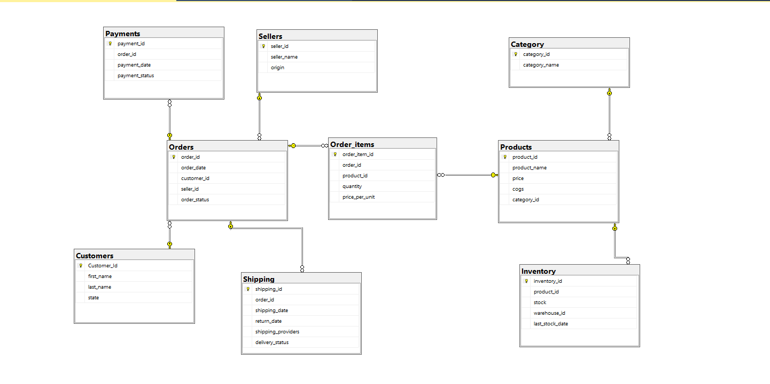

**EXPLORATORY DATA ANALYSIS**

SELECT * FROM category;

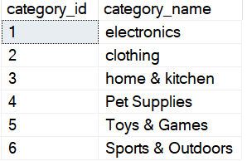

SELECT * FROM Orders;

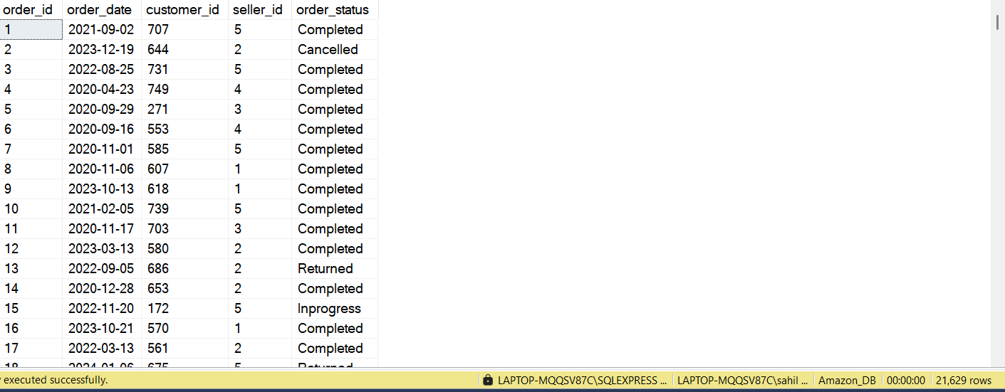

SELECT * FROM Order_items;

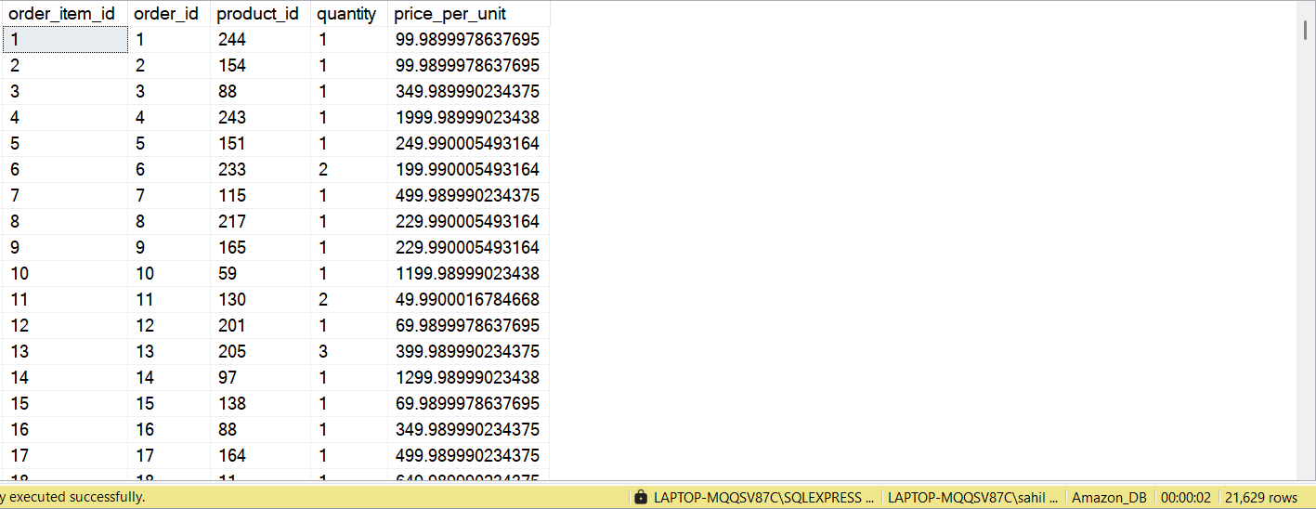

SELECT * FROM Customers;

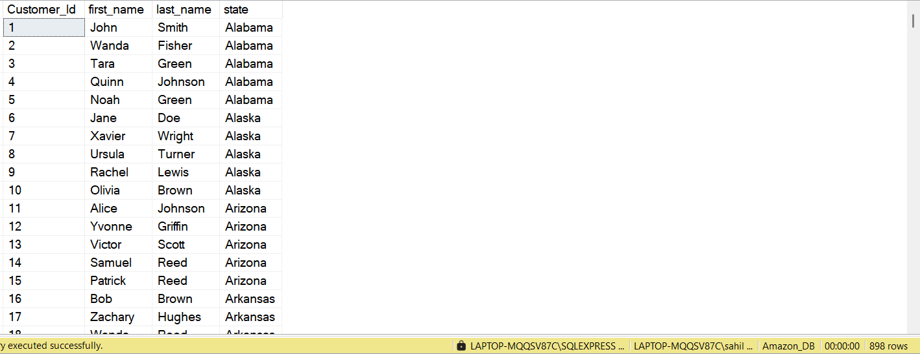

SELECT * FROM Payments;

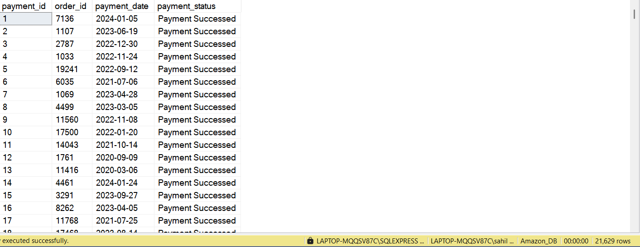

SELECT DISTINCT payment_status FROM Payments;

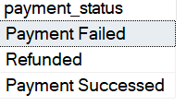

SELECT DISTINCT order_status FROM Orders;

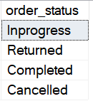

SELECT * FROM Inventory;

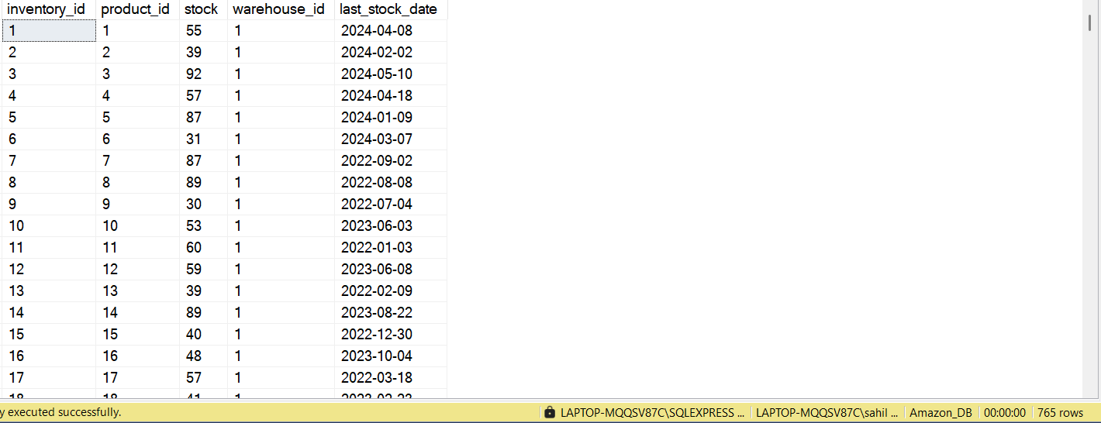

SELECT * FROM Shipping;

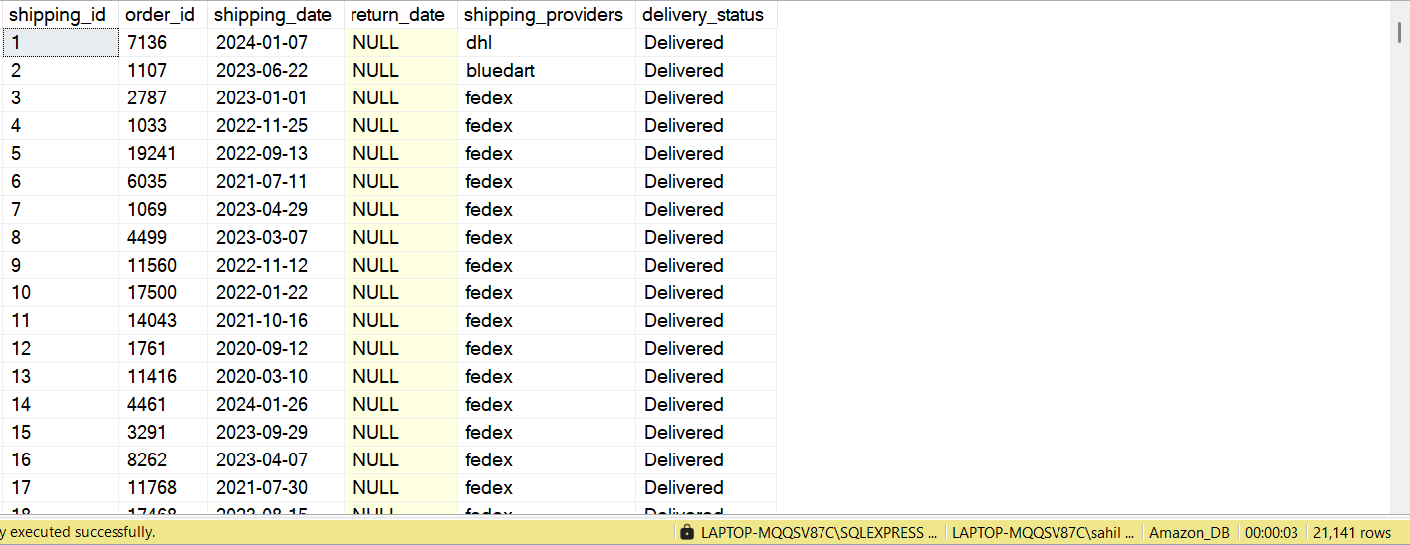

SELECT DISTINCT delivery_status FROM Shipping;

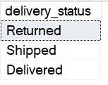

SELECT * FROM Shipping

WHERE return_date IS NOT NULL

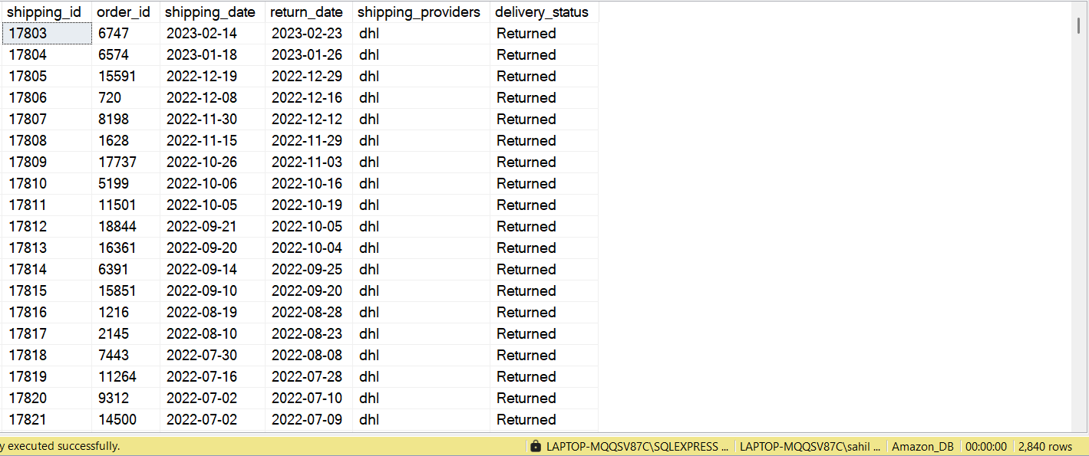

**This means 2,840 products were returned**

SELECT * FROM Orders

WHERE order_id= 6747

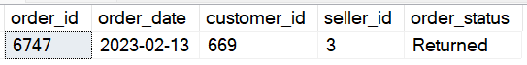

**Here you can verify that Order_id with 6747 which has return date in shipping table also has Returned status in Orders table**

**This is how we have verified that data follows the Integrity**

SELECT COUNT(*) Nr_of_Delivered_and_Retained_Orders

FROM Shipping

WHERE return_date IS NULL

AND delivery_status = 'delivered';

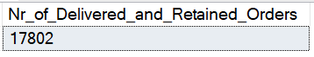

**Task 2 : Top Selling Products**

**Query the Top 10 Products by Total sales value.**

**Challenge: Include Product name, total quantity sold, and total sales value**

To solve this Task first I added Sales column by doing following steps and then solve the Question

ALTER TABLE Order_items

ADD Sales FLOAT;

UPDATE Order_items

SET Sales = quantity * price_per_unit;

WITH Top_Product_by_Sales

AS

(

SELECT

oi.product_id,

p.product_name,

SUM(oi.quantity) Total_Quantity_Sold,

CAST(SUM(Sales) as decimal(10,2)) Total_Sales

FROM Orders o

LEFT JOIN Order_items oi

ON o.order_id= oi.order_id

LEFT JOIN Products p

ON oi.product_id = p.product_id

GROUP BY

oi.product_id,

p.product_name

)

SELECT TOP 10 * FROM Top_Product_by_Sales

ORDER BY Total_Sales DESC;

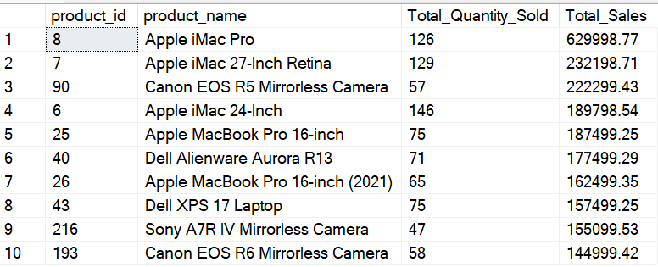

**Task 3 Revenue by Category**

**Calculate total revenue generated by each product category.**

**Challenge: Include the percentage contribution of each category to total revenue**

SELECT

p.category_id,

c.category_name,

CAST(SUM(oi.Sales) as decimal(10,2)) as Total_Sales_by_Category,

CAST(SUM(oi.Sales)/(SELECT SUM(Sales) FROM Order_items) * 100 as decimal(10,2)) Percent_Contribution

FROM Order_items oi

LEFT JOIN Products p

ON oi.product_id = p.product_id

LEFT JOIN Category c

ON c.category_id = p.category_id

Group by

p.category_id,

c.category_name

ORDER BY

CAST(SUM(oi.Sales) as decimal(10,2)) DESC

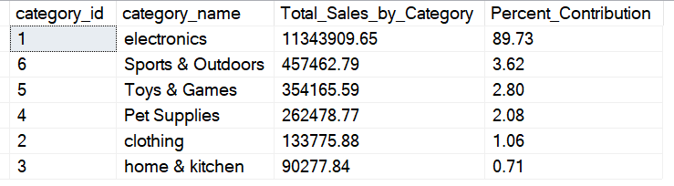

**Task 4 : Average Order Value (AOV)**

**Compute the average Order value for each customer**

**Challenge: Include Only the Customers with more than 5 Orders**

SELECT

c.Customer_Id,

CONCAT(c.first_name,' ', c.last_name) Customer_Name,

ROUND(SUM(oi.Sales)/COUNT(o.order_id),2) Avg_Order_Value,

COUNT(o.order_id) Nr_of_Orders

FROM Orders o

LEFT JOIN Order_items oi

ON oi.order_id = o.order_id

LEFT JOIN Customers c

ON o.customer_id = c.Customer_Id

GROUP BY

c.Customer_Id,

c.first_name,

c.last_name

HAVING COUNT(o.order_id) > 5

ORDER BY

SUM(oi.Sales)/COUNT(o.order_id) DESC

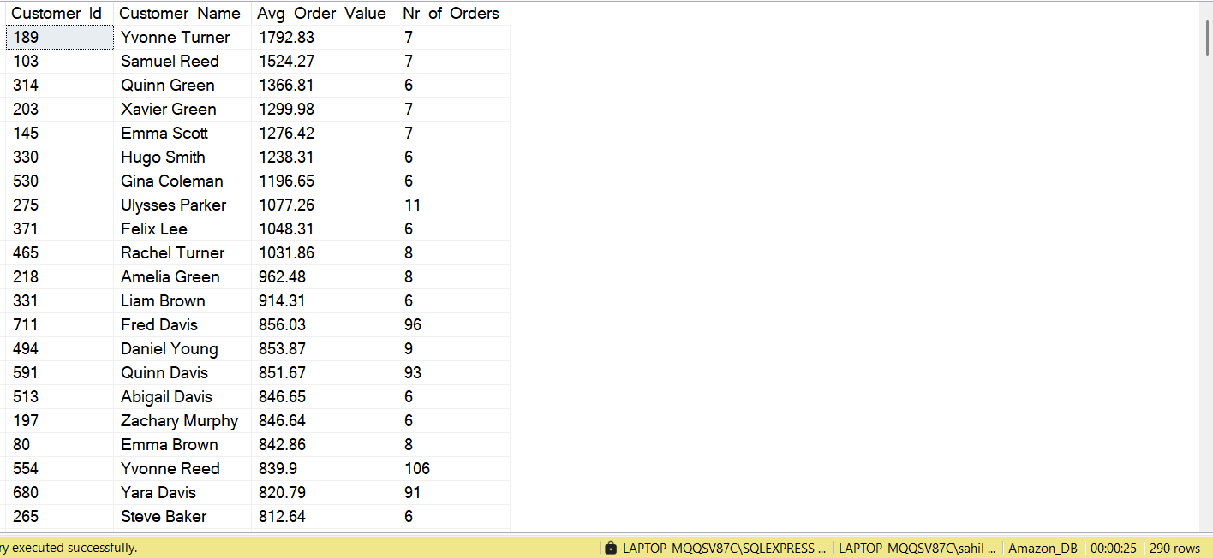

**Task 5 Monthly Sales Trend**

**Query Monthly Total Sales Over the Past year.**

**Challenge: Display the sales trend, grouping by month, return current_month_sales, Last Month Sales**

WITH Monthly_Trend_2023

AS

(

SELECT

YEAR(order_date) Year,

MONTH(order_date) Month_Num,

DATENAME(MONTH, o.order_date) Month_Name,

ROUND(SUM(Sales),2) Current_Month_Sales,

ROUND(LAG(SUM(Sales)) OVER(ORDER BY MONTH(order_date)),2) Prev_Month_Sales

FROM Orders o

JOIN Order_items oi

ON o.order_id = oi.order_id

WHERE YEAR(order_date) = 2023

GROUP BY

YEAR(order_date),

MONTH(order_date) ,

DATENAME(MONTH, o.order_date)

)

SELECT

Year,

Month_Name,

Current_Month_Sales,

Prev_Month_Sales,

ROUND((Current_Month_Sales - Prev_Month_Sales)/Prev_Month_Sales * 100,2) Pecent_Growth_Rate

FROM Monthly_Trend_2023

ORDER BY Year, Month_Num

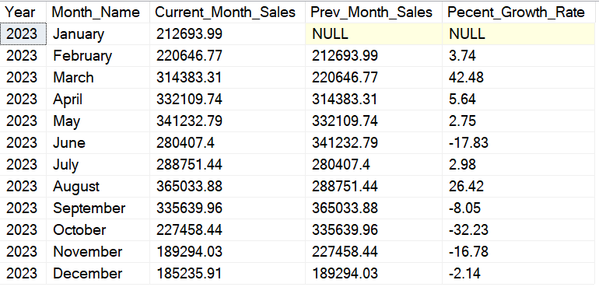

-- Here I have gone One step further and applied Monthly trend for all four years

WITH Monthly_Trend AS

(

SELECT

YEAR(order_date) AS Year,

MONTH(order_date) AS Month_Num,

DATENAME(MONTH, order_date) AS Month_Name,

ROUND(SUM(Sales), 2) AS Current_Month_Sales,

LAG(SUM(Sales)) OVER (ORDER BY YEAR(order_date), MONTH(order_date)) AS Prev_Month_Sales

FROM Orders o

JOIN Order_items oi

ON o.order_id = oi.order_id

GROUP BY

YEAR(order_date),

MONTH(order_date),

DATENAME(MONTH, order_date)

)

SELECT

Year,

Month_Name,

Current_Month_Sales,

Prev_Month_Sales,

ROUND((Current_Month_Sales - Prev_Month_Sales) / NULLIF(Prev_Month_Sales, 0) * 100, 2) AS Percent_Growth_Rate

FROM Monthly_Trend

ORDER BY Year, Month_Num;

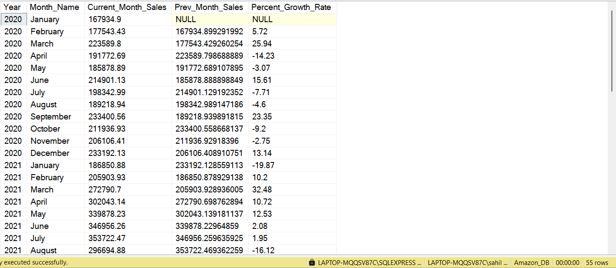

**Year Over Year Analysis**

WITH Yearly_Trend_Analysis

AS

(

SELECT

DISTINCT YEAR(order_date) Years,

ROUND(SUM(Sales),2) Current_Year_Sales,

ROUND(LAG(SUM(Sales)) OVER (ORDER BY YEAR(order_date)),2) AS Prev_Year_Sales

FROM Orders o

JOIN Order_items oi

ON o.order_id = oi.order_id

GROUP BY

YEAR(order_date)

)

SELECT

Years,

Current_Year_Sales,

Prev_Year_Sales,

ROUND((Current_Year_Sales - Prev_Year_Sales)/Prev_Year_Sales * 100,2) Percent_Growth_Rate

FROM Yearly_Trend_Analysis

ORDER BY Years

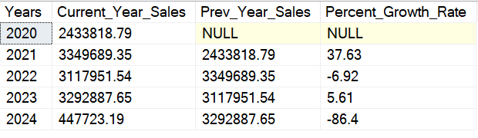

**Task 6: Customers with No purchases**

**Find the Customer registered but never placed an order**

**Challenge: List customer details and the time since their registration.**

**Solution:**

**To demonstrate my understanding of SQL queries and showcase multiple ways to solve the**

**problem effectively, I have utilized three different approaches. Each approach achieves the same goal but employs distinct techniques to illustrate versatility in SQL**

SELECT * FROM Customers

WHERE customer_id IN

(

SELECT

DISTINCT c.Customer_Id

FROM Customers c

LEFT JOIN Orders o

ON o.customer_id = c.Customer_Id

WHERE order_id IS NULL

GROUP BY c.Customer_Id

)

ORDER BY Customer_Id

APPROACH 2

SELECT * FROM Customers

WHERE customer_id IN

(

SELECT

DISTINCT c.Customer_Id

FROM Customers c

LEFT JOIN Orders o

ON o.customer_id = c.Customer_Id

GROUP BY c.Customer_Id

HAVING COUNT(o.order_id) = 0

)

ORDER BY Customer_Id

SMART Approach

SELECT * FROM Customers

WHERE Customer_Id NOT IN

(SELECT DISTINCT Customer_Id

FROM Orders)

ORDER BY Customer_Id

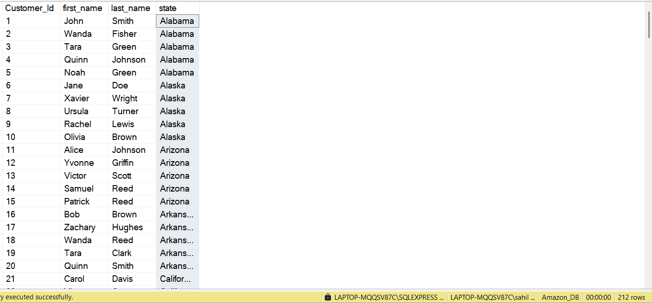

**Task 7 : Best Selling Category by State**

**Identify the best-selling product for each state**

**Challenge: Include the Total Sales for that category within each State.**

**I have identified the Top 3 categories for each state to provide a focused analysis of the most significant contributors. Notably, the Electronics category accounts for approximately 89% of total sales, which highlights its dominant impact. This analysis allows stakeholders to make informed decisions based on the Top 3 categories, or expand the scope to the Top 5 or Top 10 categories if needed, depending on their strategic preferences**

WITH Best_Selling_Category_by_State

AS

(

SELECT

c.state as State,

ct.category_name Category,

ROUND(SUM(oi.Sales),2) Total_Sales_by_Category,

RANK() OVER(PARTITION BY c.state ORDER BY SUM(Sales) DESC) Rank

FROM Orders o

LEFT JOIN Customers c

ON c.Customer_Id = o.customer_id

LEFT JOIN Order_items oi

ON oi.order_id = o.order_id

LEFT JOIN Products p

ON p.product_id = oi.product_id

LEFT JOIN Category ct

ON ct.category_id = p.category_id

GROUP BY

c.state,

ct.category_name

)

SELECT State,Category,Total_Sales_by_Category, Rank FROM Best_Selling_Category_by_State

WHERE Rank <= 3

ORDER BY

State,

Total_Sales_by_Category DESC

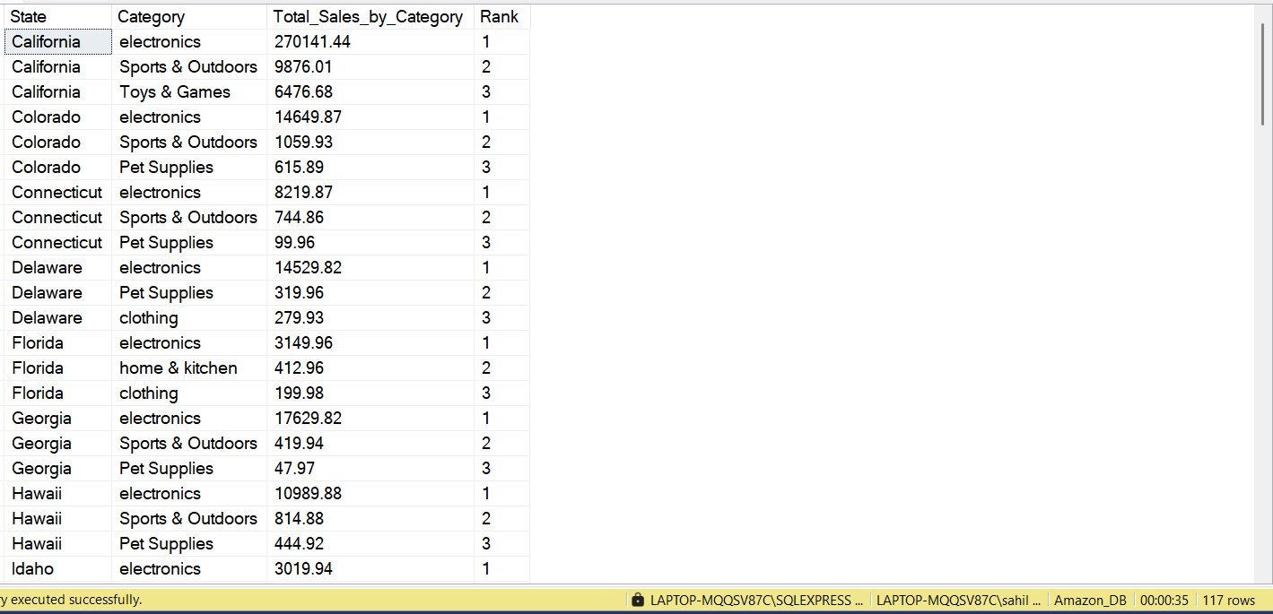

**Task 8 : Least Selling Category by State**

**Identify the least-selling product for each state**

**Challenge: Include the Total Sales for that category within each State.**

WITH Sales_Category_by_State

AS

(

SELECT

c.state as State,

ct.category_name Category,

ROUND(SUM(oi.Sales),2) Total_Sales_by_Category,

RANK() OVER(PARTITION BY c.state ORDER BY SUM(Sales) ASC) Rank

FROM Orders o

LEFT JOIN Customers c

ON c.Customer_Id = o.customer_id

LEFT JOIN Order_items oi

ON oi.order_id = o.order_id

LEFT JOIN Products p

ON p.product_id = oi.product_id

LEFT JOIN Category ct

ON ct.category_id = p.category_id

GROUP BY

c.state,

ct.category_name

)

SELECT State,Category,Total_Sales_by_Category, Rank

FROM Sales_Category_by_State

WHERE Rank = 1

ORDER BY

State,

Total_Sales_by_Category

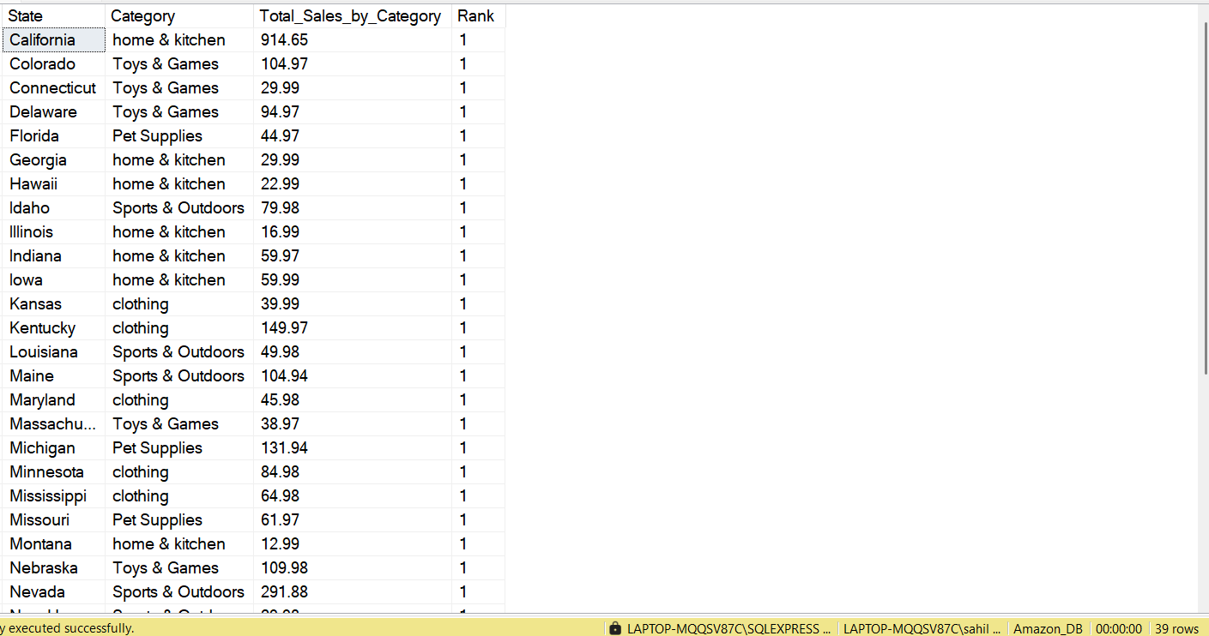

**Task 9 Customer Lifetime Value**

**Calculate the total value of orders placed by each customer over their lifetime.**

**Challenge: Rank customers based on their Customer Lifetime Sales**

SELECT

c.customer_id,

Concat(c.first_name,' ' ,c.last_name) Customer_Name,

FORMAT(ROUND(SUM(oi.Sales),2),'N') Customer_Lifetime_Sales,

DENSE_RANK() OVER(ORDER BY ROUND(SUM(oi.Sales),2) DESC) Rank

FROM Orders o

LEFT JOIN Customers c

ON c.Customer_Id = o.customer_id

LEFT JOIN Order_items oi

ON oi.order_id = o.order_id

GROUP BY c.customer_id, c.first_name, c.last_name

ORDER BY SUM(oi.Sales) DESC

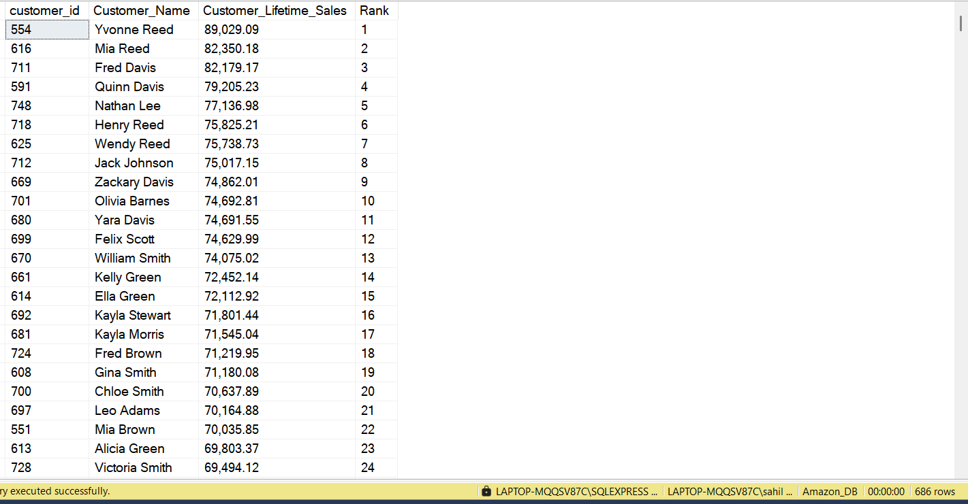

**Task 10 Inventory Stock Alerts**

**Query Products with stock levels below a certain threshold(e., less than 10 units)**

**Challenge: Include last restock date and warehouse information**

SELECT

i.product_id,

p.product_name,

stock,

i.warehouse_id ,

last_stock_date

FROM Inventory i

JOIN Products p

ON i.product_id = p.product_id

WHERE stock < 10

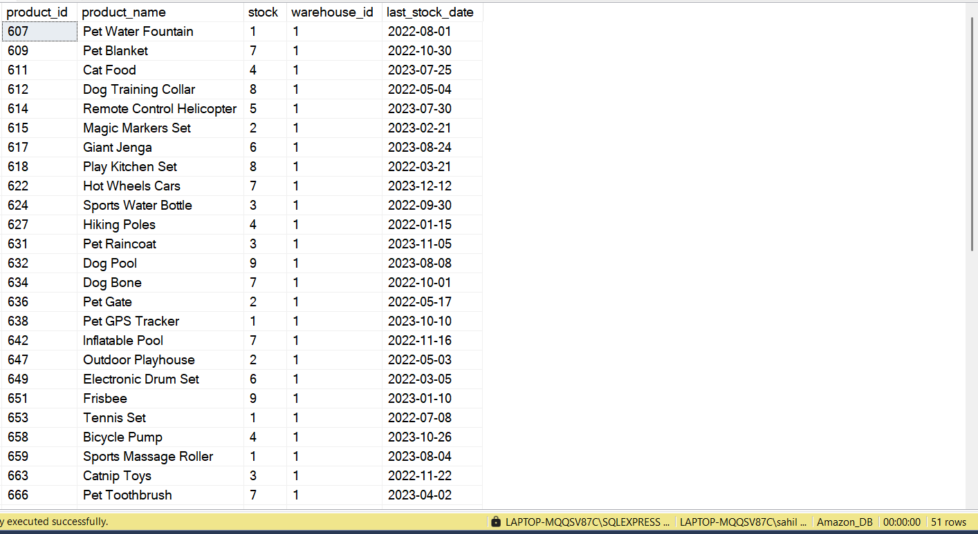

**Task 11 Shipping Delays**

**Identify orders where the shipping date is later than 4 days after the order date.**

**Challenge: Include customer, Order details, and delivery provider.**

SELECT

c.Customer_Id,

CONCAT(c.first_name,' ' ,c.last_name) Customer_Name,

o.*,

shipping_providers,

DATEDIFF(DAY,o.order_date, sh.shipping_date) Days_took_to_ship

FROM Orders o

LEFT JOIN Shipping sh

ON sh.order_id = o.order_id

LEFT JOIN Customers c

ON c.Customer_Id = o.customer_id

WHERE DATEDIFF(DAY,o.order_date, sh.shipping_date) > 4

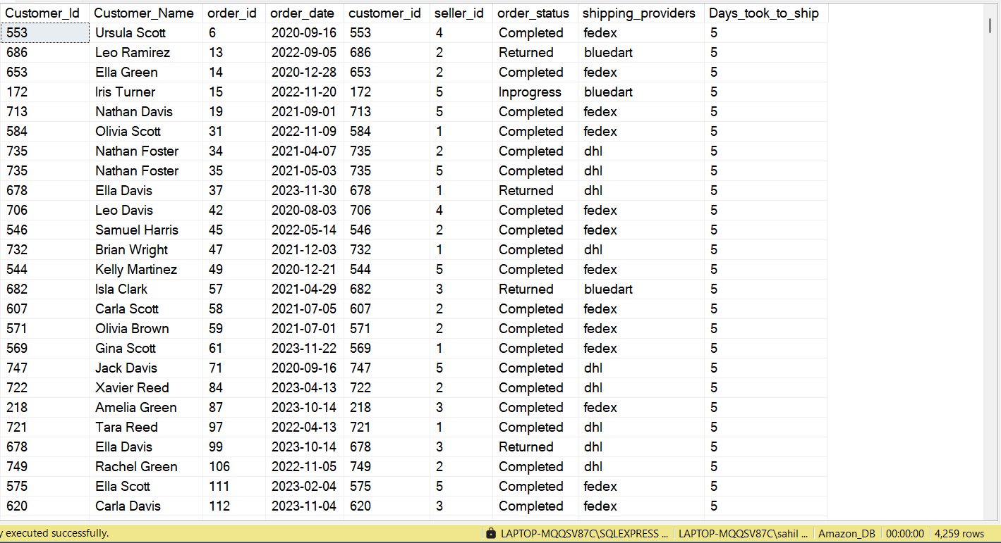

**Task 12 Payment Success Rate**

**Calculate the Percentage of successful payments, access all orders.**

**Challenge: Include breakdown by Payment status (eg., Failed,pending)**

SELECT

p.payment_status Payment_Status,

COUNT(p.payment_id) Nr_of_payments,

ROUND(CAST(COUNT(p.payment_id) AS FLOAT)/

(SELECT COUNT(payment_id) FROM Payments) * 100, 2) AS Percent_Breakdown

FROM Orders o

LEFT JOIN Payments p

ON p.order_id = o.order_id

GROUP BY p.payment_status

ORDER BY Percent_Breakdown DESC

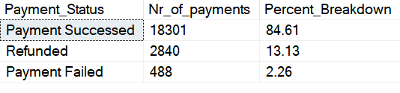

**Task 13 Top Performing Sellers**

**Find the Top 5 sellers based on total Sales value.**

**Challenge: Include both successful and failed Orders, and Display their percentage of**

**successful Orders**

**Here, I have solved Solved this question in three phases, and In each phase of Query I have given insights at different level, so that Stakeholders can Get Insight at different Granularity**

SELECT TOP 5

s.seller_id,

s.seller_name,

FORMAT(ROUND(SUM(oi.Sales),2),'N') Total_Sales_by_Sellers

FROM Orders o

JOIN Order_items oi

ON oi.order_id = o.order_id

JOIN Sellers s

ON s.seller_id = o.seller_id

GROUP BY

s.seller_id,

s.seller_name

ORDER BY

ROUND(SUM(oi.Sales),2) DESC

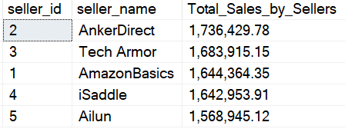

----------------------------------------------------------------------

**Top 5 Best Sellers by Total Sales and Percentage Order Distribution based On Order_Status**

WITH Top_Sellers

AS

(

SELECT TOP 5

s.seller_id,

s.seller_name,

ROUND(SUM(oi.Sales),2) Total_Sales

FROM Orders o

JOIN Order_items oi

ON oi.order_id = o.order_id

JOIN Sellers s

ON s.seller_id = o.seller_id

GROUP BY

s.seller_id,

s.seller_name

ORDER BY

Total_Sales DESC

),

Seller_Orders_Statuses

as

(

SELECT

seller_id,

order_status,

CAST(COUNT(*) as float) Nr_Orders_By_Seller

FROM Orders

GROUP BY seller_id, order_status

),

Total_Orders

AS

(SELECT Seller_id, COUNT(order_status) Total_Orders_by_Each_Seller

FROM Orders

GROUP BY Seller_id

)

SELECT

ts.seller_id,

ts.seller_name,

ts.Total_Sales,

sos.order_status,

Nr_Orders_By_Seller,

-- Total_Orders_by_Each_Seller,

ROUND((Nr_Orders_By_Seller/Total_Orders_by_Each_Seller) * 100,2) Percent_of_Orders

FROM Top_Sellers ts

LEFT JOIN Seller_Orders_Statuses sos

ON sos.seller_id = ts.seller_id

LEFT JOIN Total_Orders ot

ON ot.seller_id = ts.seller_id

ORDER BY

ts.Total_Sales DESC;

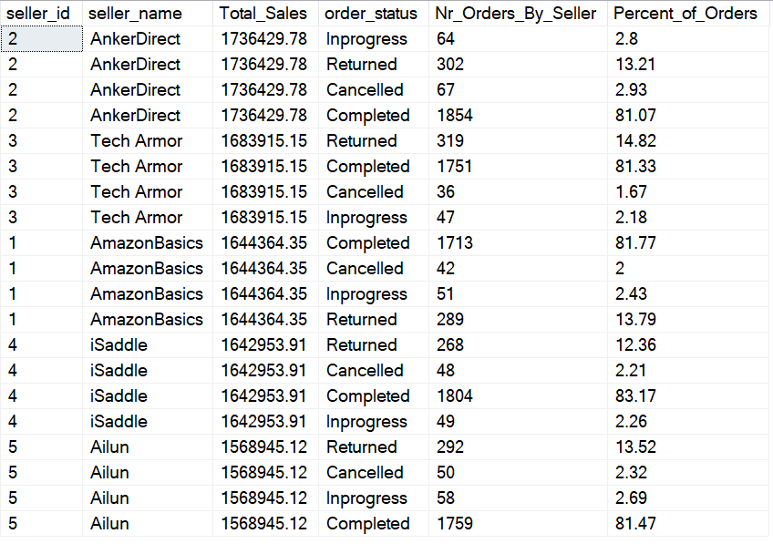

**Final Solution of Task 13**

**Top 5 Sellers by Total Revenue and Percentage distributio of Cancelled Orders and Completed**

**orders**

WITH Top_Sellers

AS

(

SELECT TOP 5

s.seller_id,

s.seller_name,

ROUND(SUM(oi.Sales),2) Total_Sales

FROM Orders o

JOIN Order_items oi

ON oi.order_id = o.order_id

JOIN Sellers s

ON s.seller_id = o.seller_id

GROUP BY

s.seller_id,

s.seller_name

ORDER BY

Total_Sales DESC

),

Seller_Orders_Statuses

as

(

SELECT

seller_id,

order_status,

CAST(COUNT(*) as float) Nr_Orders_By_Seller

FROM Orders

GROUP BY seller_id, order_status

),

Total_Orders

AS

(SELECT Seller_id, COUNT(order_status) Total_Orders_by_Each_Seller

FROM Orders

WHERE

order_status != 'Inprogress'

AND

order_status != 'returned'

GROUP BY Seller_id

)

SELECT

ts.seller_id,

ts.seller_name,

ts.Total_Sales,

sos.order_status,

Nr_Orders_By_Seller,

Total_Orders_by_Each_Seller,

ROUND((Nr_Orders_By_Seller/Total_Orders_by_Each_Seller) * 100,2) Percent_of_Orders

FROM Top_Sellers ts

LEFT JOIN Seller_Orders_Statuses sos

ON sos.seller_id = ts.seller_id

LEFT JOIN Total_Orders ot

ON ot.seller_id = ts.seller_id

WHERE

order_status != 'Inprogress'

AND

order_status != 'returned'

ORDER BY

ts.Total_Sales DESC

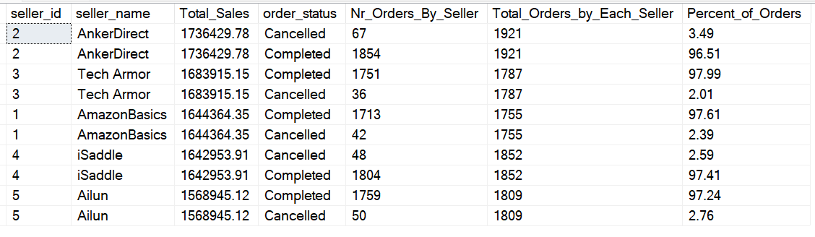

**Task 14 Product Profit Margin**

**Calculate the profit margin for much product (difference between price and cost of goods sold)**

**Challenge: Rank products by their profit margin, showing highest to lowest**

**Here I have gone one step ahead and calculated Profit Margin Percentage**

WITH Profit_Margin

AS

(

SELECT

p.product_id,

p.product_name,

ROUND(SUM(oi.Sales - (p.cogs * oi.quantity)),2) Profit,

ROUND(SUM(oi.Sales),2) Total_Sales

FROM Orders o

LEFT JOIN Order_items oi

ON oi.order_id = o.order_id

LEFT JOIN Products p

ON oi.product_id = p.product_id

GROUP BY

p.product_id,

p.product_name

)

SELECT

product_id,

product_name,

Profit,

ROUND((Profit/Total_Sales),4) * 100 Profit_Margin_Percentage ,

DENSE_RANK() OVER(ORDER BY Profit DESC) Rank_by_Margin

FROM Profit_Margin

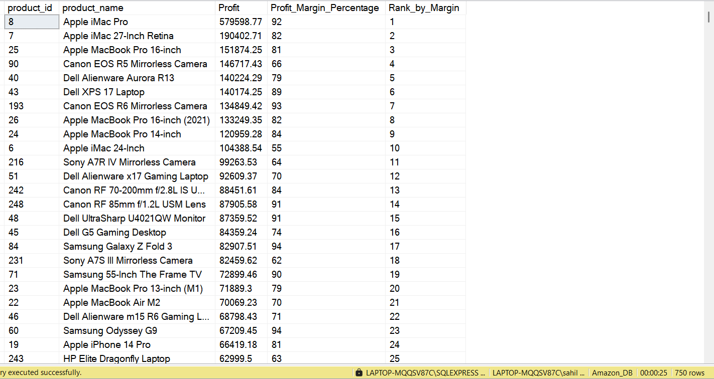

**Task 15 Most Returned Products**

**Query the top 10 products by the number of return.**

**Challenge: Display the return rate as a percentage of total unitssold for each product**

WITH Top_Returned_Products AS (

SELECT

p.product_id,

p.product_name,

SUM(CASE WHEN o.order_status = 'returned' THEN oi.quantity ELSE 0 END) AS Nr_of_return_Units,

SUM(oi.quantity) AS Total_Unit_Sold

FROM Orders o

INNER JOIN Order_items oi ON oi.order_id = o.order_id

INNER JOIN Products p ON p.product_id = oi.product_id

GROUP BY p.product_id, p.product_name

)

SELECT TOP 10

product_id,

product_name,

Nr_of_return_Units,

Total_Unit_Sold,

ROUND((CAST(Nr_of_return_Units AS FLOAT) / NULLIF(Total_Unit_Sold, 0)) * 100, 2) AS Percent_Return

FROM Top_Returned_Products

ORDER BY Nr_of_return_Units DESC;

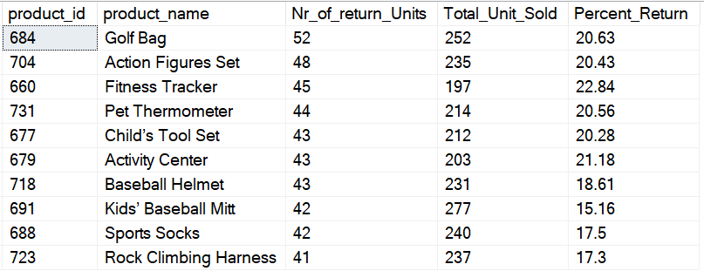

**Product Order Status and Sales Performance Summary**

WITH Total_Orders_of_Products_by_Order_Status AS (

SELECT

p.product_id,

p.product_name,

o.order_status,

SUM(oi.quantity) AS Nr_of_Units

FROM Orders o

LEFT JOIN Order_items oi

ON oi.order_id = o.order_id

LEFT JOIN Products p

ON p.product_id = oi.product_id

--WHERE p.category_id = 1 -- You can filter Products by Category Id

--AND

--YEAR(order_date) = 2024 -- You can filter by Year

GROUP BY p.product_id, p.product_name, o.order_status

),

Total_Orders_of_Each_Products AS (

SELECT

p.product_id,

SUM(oi.quantity) AS Total_Units_by_Product

FROM Orders o

LEFT JOIN Order_items oi

ON oi.order_id = o.order_id

LEFT JOIN Products p

ON p.product_id = oi.product_id

-- Where YEAR(order_date) = 2024 -- You can filer by Year

-- AND

-- p.category_id = 1 -- You can filter Products by Category Id

GROUP BY p.product_id

),

Product_Order_Summary AS (

SELECT

tobos.product_id,

tobos.product_name,

tobos.order_status,

tobos.Nr_of_Units,

tooep.Total_Units_by_Product

FROM Total_Orders_of_Products_by_Order_Status tobos

JOIN Total_Orders_of_Each_Products tooep

ON tobos.product_id = tooep.product_id

)

SELECT TOP 10

product_id,

product_name,

order_status,

Nr_of_Units,

Total_Units_by_Product,

ROUND((CAST(Nr_of_Units AS FLOAT) / NULLIF(Total_Units_by_Product, 0)) * 100, 2) AS Percentage -- FIX: Prevent division by zero

--WHERE Nr_of_Units > 100 -- You can filter by Nr of units

--WHERE order_status = 'Completed' -- You can filer by Order_statuses like Completed, Inprogress, Complete, Returned

FROM Product_Order_Summary

ORDER BY Total_Units_by_Product DESC, product_id;

**This query provides key insights into product sales and order status:**

**Order Distribution: Track product performance across different order statuses**

**(Completed, In Progress, Returned).**

**Product Performance: Identify top-selling and underperforming products by comparing units sold to**

**total units.**

**Percentage Breakdown: View the percentage of units sold in each status to spot trends**

**(e.g., returns or unfulfilled orders).**

**Filters You Can Apply:**

**Product Category: p.category_id = 1 to analyze specific product categories.**

**Year: YEAR(order_date) = 2024 to focus on a particular year's data.**

**Order Status: order_status = 'Completed' (or other statuses) to focus on specific order types.**

**Units Sold: Nr_of_Units > 100 to filter products with significant sales.**

**These filters will help you get focused insights on sales, product performance, and order trends.**

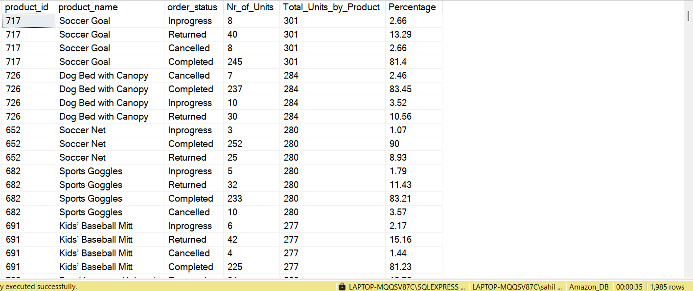

**Task 16 Inactive Sellers**

**Identify Seller who haven't made any sales in the Last 6 months**

**Challenge : Show the last sale date and total sales from those sellers**

SELECT MAX(order_date) Last_Order_Date FROM Orders



**Since this dataset is 1 year old as I am doing this project at Jan 2025**

**So I will consider '2024-08-01' as My Today's date**

SELECT DATEADD(MONTH,-6, '2024-08-01') Date_before_6_Months;

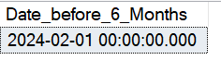

**order_date before 6 months that is '2024-02-01'**

WITH Seller_cte

AS

(

SELECT

seller_id,

seller_name,

origin

FROM Sellers

WHERE Seller_id NOT IN

(

SELECT DISTINCT seller_id FROM Orders

WHERE order_date > DATEADD(MONTH,-6, '2024-08-01'))

),

Seller_cte2

AS

(

SELECT

s.seller_id,

MAX(order_date) Last_date_Sale,

SUM(oi.Sales) Total_Sales

FROM Orders o

JOIN Sellers s

ON o.seller_id = s.seller_id

JOIN Order_items oi

ON oi.order_id = o.order_id

WHERE

o.seller_id IN (SELECT seller_id FROM Seller_cte)

GROUP BY s.seller_id

)

SELECT

sc1.seller_id,

sc1.seller_name,

sc1.origin,

sc2.Last_date_Sale,

COALESCE(sc2.Total_Sales,0) Total_Sales

FROM Seller_cte sc1

LEFT JOIN Seller_cte2 sc2

ON sc1.seller_id =sc2.seller_id

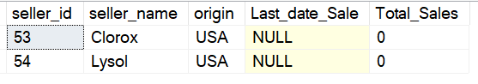

**Task 17 Identify customers into returning or new**

**if the customer has done more than 5 return categorize them as returning otherwise new**

**challenge: List customers id, name, total orders, total returns**

WITH Customers_Orders_Summary

AS

(

SELECT

c.Customer_Id,

CONCAT(c.first_name,' ' ,c.last_name) Customer_Full_Name,

COUNT( DISTINCT o.order_id) Total_Orders,

COALESCE(SUM(CASE WHEN

O.order_status = 'Returned'

THEN 1 ELSE 0 END ),0) Nr_of_Returns

FROM Customers c

JOIN Orders o

ON c.Customer_Id = o.customer_id

GROUP BY

c.Customer_Id,

c.first_name,

c.last_name

)

SELECT * ,

CASE

WHEN Nr_of_Returns > 5 THEN 'Returning_Customer'

ELSE 'New_Customer'

END New_Category

FROM Customers_Orders_Summary

ORDER BY Total_Orders DESC

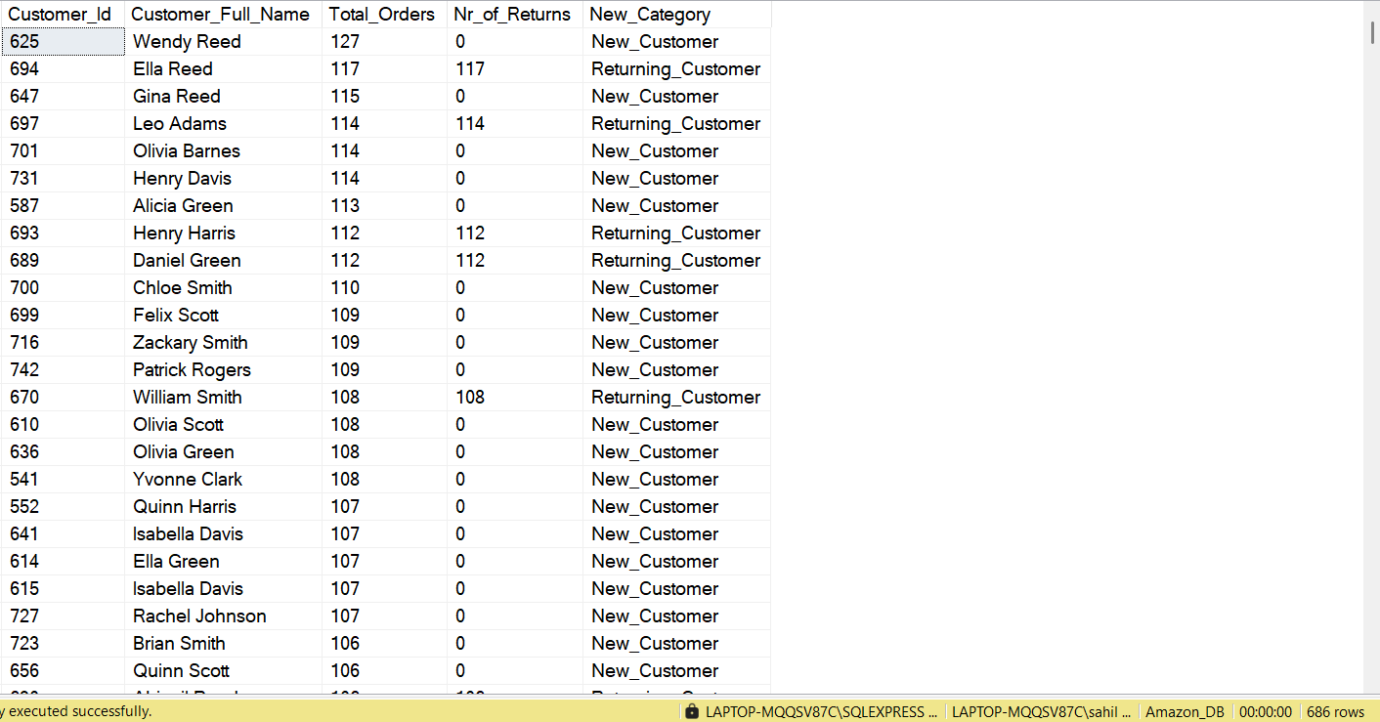

**Task 18: Top 5 Customers by Orders in Each State**

**Identify the Top 5 Customers with the Highest number of Orders for Each State.**

**Challenge: Include the Number of Orders and total Sales for each Customer.**

SELECT * FROM

(

SELECT

c.state,

c.Customer_Id,

CONCAT(c.first_name,' ' ,c.last_name) Customer_Full_Name,

COUNT(o.order_id) Total_Orders,

ROUND(SUM(oi.Sales),2) Total_Sales,

DENSE_RANK() OVER(PARTITION BY c.state ORDER BY COUNT(o.order_id) DESC) Rank_by_Orders

FROM Orders o

JOIN Customers c

ON o.customer_id = c.Customer_Id

JOIN Order_items oi

ON oi.order_id = o.order_id

GROUP BY

c.state,

c.Customer_Id,

c.first_name,

c.last_name

) t1

WHERE Rank_by_Orders <= 5

ORDER BY state

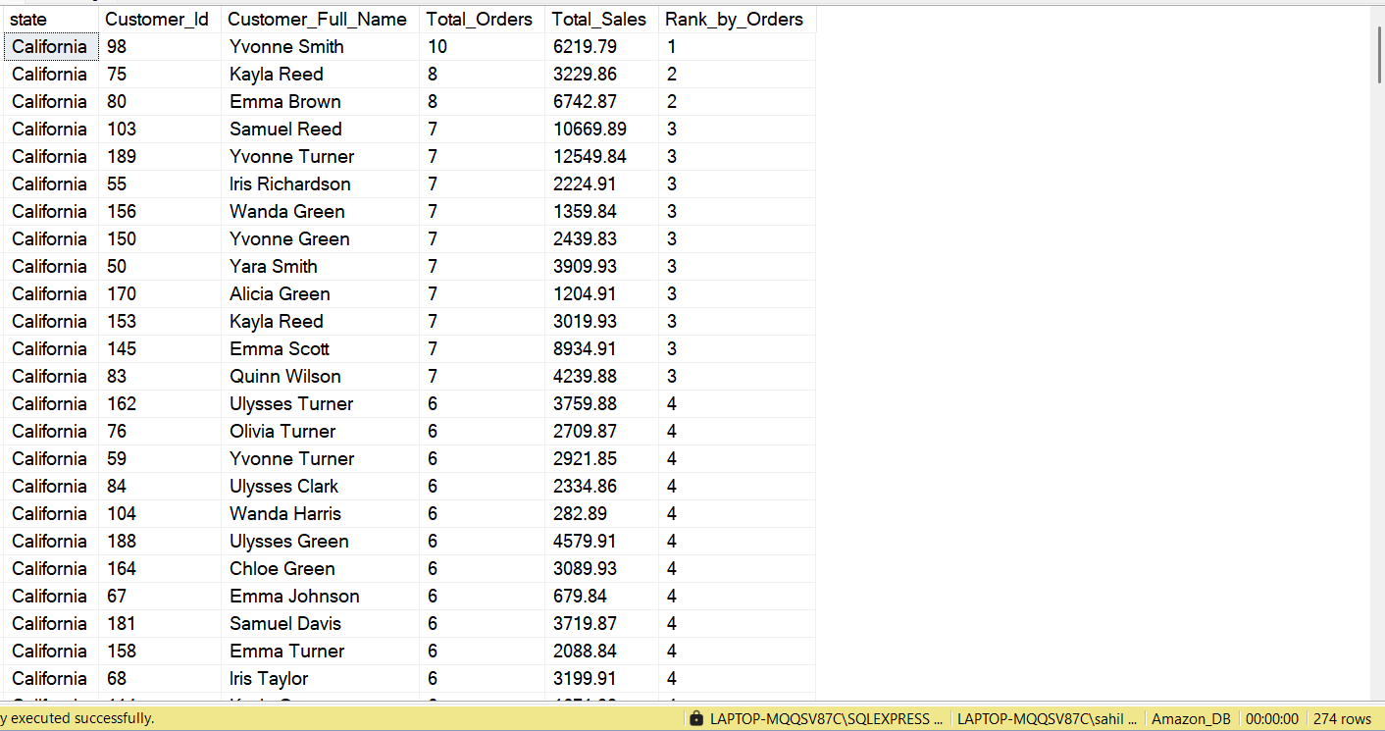

**Task 20: Revenue by Shipping Provider**

**Calculate the Total Revenue handled by each shipping provider.**

**Challenge: Include the Total Number of Orders handled and the Average delivery time for each provider**

SELECT

sh.shipping_providers,

ROUND(SUM(oi.Sales),2) Total_Sales,

COUNT(o.order_id) Nr_of_Orders,

ROUND(AVG(DATEDIFF(DAY,o.order_date,sh.shipping_date)* 1.00) ,2) Time_taken_to_Deliver

FROM Orders o

JOIN Shipping sh

ON sh.order_id = o.order_id

JOIN Order_items oi

ON oi.order_id = o.order_id

GROUP BY

sh.shipping_providers

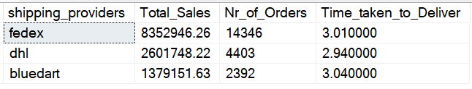

**Task 21 Top 10 Product with Highest decreasing revenue ratio compare to last year(2022) and current year(2023)**

**Challenge: Return product_id, Product_name, category_name,2022 revenue and 2023 Revenue decrease ratio at end Round the result**

WITH Product_2023

AS

(

SELECT

p.product_id,

p.product_name,

c.category_name,

ROUND(SUM(oi.Sales),2) Total_Sales_2023

FROM Orders o

JOIN Order_items oi

ON o.order_id = oi.order_id

JOIN Products p

ON p.product_id = oi.product_id

JOIN Category c

ON c.category_id = p.category_id

WHERE YEAR(o.order_date) = 2023

GROUP BY

p.product_id,

p.product_name,

c.category_name

), Product_2022

AS

(

SELECT

p.product_id,

p.product_name,

c.category_name,

ROUND(SUM(oi.Sales),2) Total_Sales_2022

FROM Orders o

JOIN Order_items oi

ON o.order_id = oi.order_id

JOIN Products p

ON p.product_id = oi.product_id

JOIN Category c

ON c.category_id = p.category_id

WHERE YEAR(o.order_date) = 2022

GROUP BY

p.product_id,

p.product_name,

c.category_name)

, Product_Sales_Comparison_2022_2023

AS

(

SELECT

pr23.product_id as Product_Id,

pr23.product_name as Product_Name,

pr23.category_name as Category_Name,

pr22.Total_Sales_2022,

pr23.Total_Sales_2023

FROM Product_2023 pr23

LEFT JOIN Product_2022 pr22

ON pr23.product_id = pr22.product_id

)

SELECT TOP 10

Product_Id,

Product_Name,

Category_Name,

Total_Sales_2022,

Total_Sales_2023,

ROUND(CASE WHEN Total_Sales_2022 > 0 THEN (Total_Sales_2023 - Total_Sales_2022)

/ Total_Sales_2022 * 100 ELSE NULL END, 2) AS Percent_Change

FROM Product_Sales_Comparison_2022_2023

WHERE Total_Sales_2022 > Total_Sales_2023

ORDER BY Percent_Change

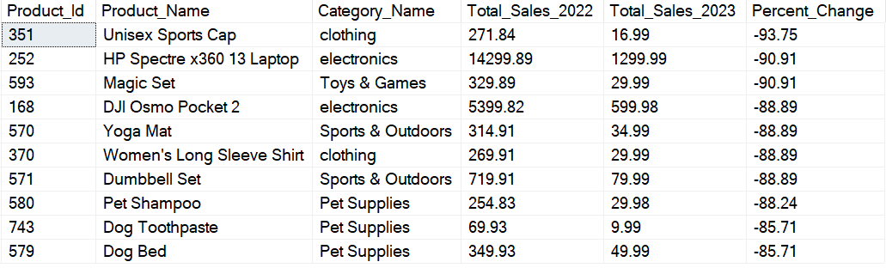

**Task 22: Store Procedure**

**Create a function as soon as the product is sold the same quantity should reduced from**

**Inventory table**

**Apple Air pode 3rd gen Product_id 1--> Stock -->45**

**Apple Airpods Max Product_id 2---> Stock---> 39**

CREATE PROCEDURE Update_Sales

@order_id INT,

@customer_id INT,

@seller_id INT,

@order_item_id INT,

@product_id INT,

@quantity INT

AS

BEGIN

-- Declaring Variables

DECLARE

@v_count INT,

@v_price FLOAT,

@v_product VARCHAR(100)

-- Checking Stock and Product Availability in Inventory

SELECT

@v_price = price,

@v_product = product_name

FROM Products

WHERE product_id = @product_id

SELECT @v_count = COUNT(*)

FROM Inventory

WHERE product_id = @product_id AND stock >= @quantity

IF @v_count > 0

BEGIN

-- Adding into Orders Table

INSERT INTO Orders(order_id, order_date, customer_id, seller_id, order_status)

VALUES (@order_id, CAST(GETDATE() AS DATE), @customer_id, @seller_id, 'Inprogress')

-- Adding into Order_items Table

INSERT INTO Order_items(order_item_id, order_id, product_id, quantity, price_per_unit, Sales)

VALUES (@order_item_id, @order_id, @product_id, @quantity, @v_price, @v_price * @quantity)

-- Updating Inventory table

UPDATE Inventory

SET stock = stock - @quantity

WHERE product_id = @product_id

PRINT 'Thank you. Product Sale: ' + @v_product + ' has been added. Inventory stock updated.'

END

ELSE

BEGIN

PRINT 'Thank you for the info. The product ' + @v_product + ' is not available.'

END

END

-------------------------------------------------------------------------------

**Scenario before Execution was this**

**Apple Air pode 3rd gen Product_id 1--> Stock -->45**

SELECT * FROM Orders**-- Nr_of_Records--> 21629**

SELECT * FROM Order_items**;-- Nr_of_Records-->21629**

**TEST 1**

EXEC Update_Sales

@order_id = 21630,

@customer_id = 2,

@seller_id = 8,

@order_item_id = 21630,

@product_id = 1,

@quantity = 10;

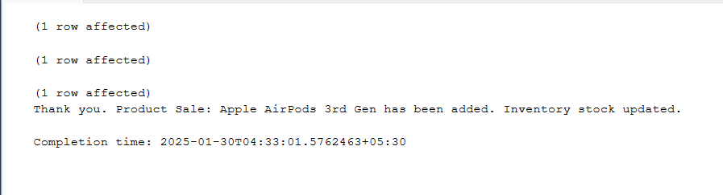

**Now after Executing Update_Sales Procedure**

SELECT * FROM Orders

-- Nr_of_Records were 21629

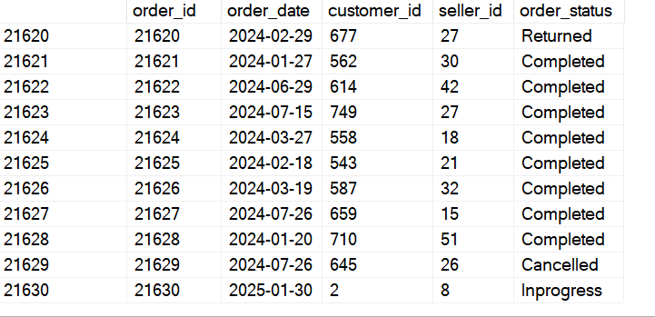

SELECT * FROM Order_items;

**-- Nr_of_Records were 21629**

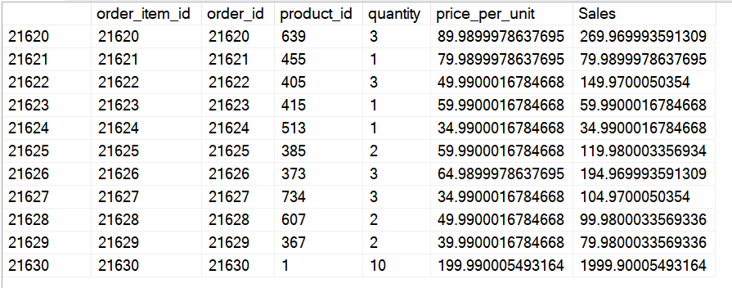

SELECT * FROM Inventory

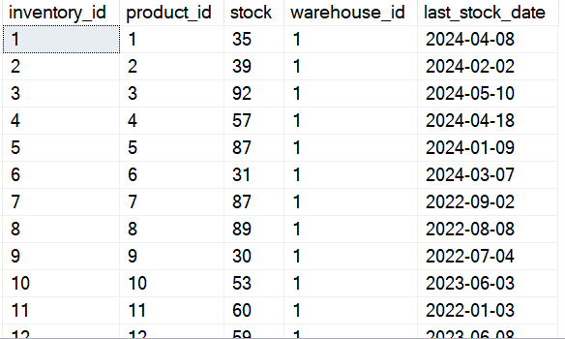

**Apple Air pode 3rd gen Product_id 1--> Stocks updated from 45 to 35**

**TEST 2**

**Before execution**

**Apple Airpods Max Product_id 2---> Stock---> 39**

**Nr_of_Records were 21630**

**Nr_of_Records were 21630**

EXEC Update_Sales

@order_id = 21631,

@customer_id = 10,

@seller_id = 4,

@order_item_id = 21631,

@product_id = 2,

@quantity = 9;

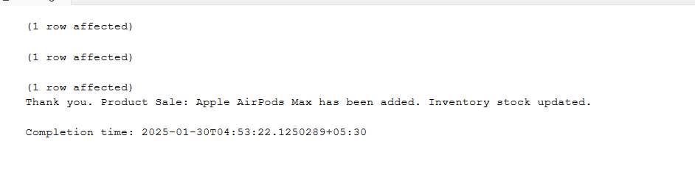

**Apple Airpods Max Product_id 2---> Stock---> 39**

SELECT * FROM Orders

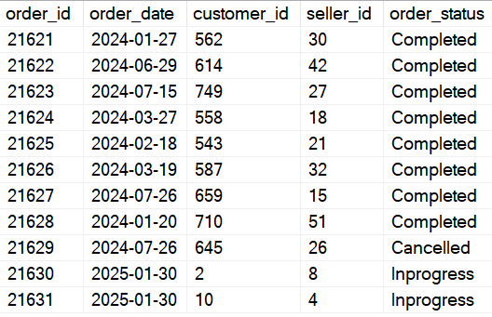

SELECT * FROM Order_items

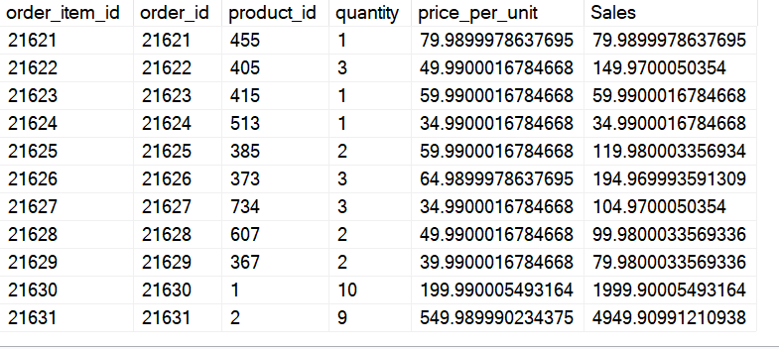

SELECT * FROM Inventory

**AS you can observe Apple Airpods Max Product_id 2**

**Stocks changed from 39 to 30 as it was sold to customer_id = 10, Hence my second test was also successful and Store Procedure is working perfectly.**

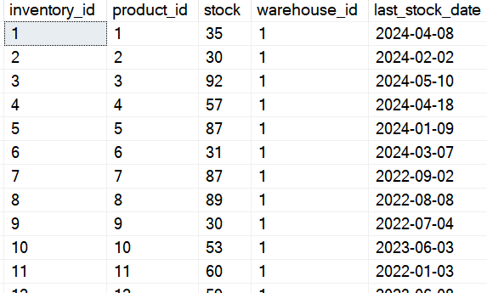

**Test 3: what if user asked for Product and its quantity is not available**

SELECT * FROM Inventory

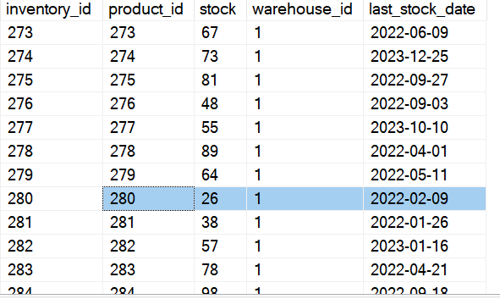

**For product_id = 280, stocks before test 3 are 26,Now if user want to retrieve 30 quantity**

**then what will happen**

EXEC Update_Sales

@order_id = 21632,

@customer_id = 11,

@seller_id = 7,

@order_item_id = 21632,

@product_id = 280,

@quantity = 30;

